What is a Virus?
- A virus is a noncellular particle made up of genetic material and protein that can invade living cells
- Structure
  - Core of nucleic acid surrounded by a protein coat called a capsid
  - Capsid can be DNA or RNA, but not both
- Core can be several to several hundred genes
Size
- Viruses are REALLY small.
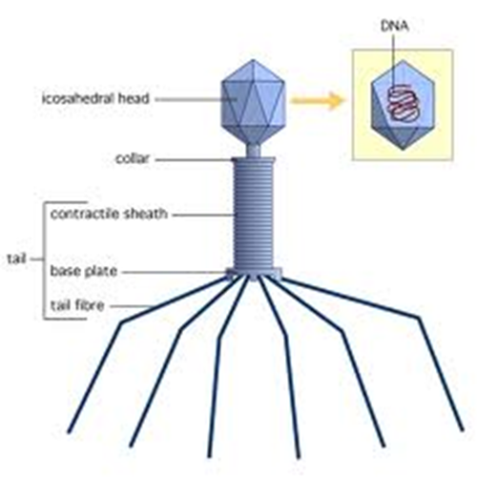
- They are much smaller than bacteria.
- They can only be seen with an electron microscope.
Bacteriophage
- Bacteriophages are viruses that infect bacteria
- Bacteriophage
- Head – capsid and DNA
- Tail – with fibers to attach to bacteria
Virus Shapes
- Round
- Rod-shaped
- Many sided
Shapes Differ, but…
- All viruses have
- Chromosome-like part that carries hereditary information – The Core
- Protein coat: Protects hereditary information and provides the shape! The Capsid
Round Viruses
- Herpes virus
  - There are two types:
    - Genital
    - oral
Rod-shaped
- Tobacco mosaic virus
Many-sided
- Bacteriophage
- Example: e. coli
Why do viruses infect us?
- Viruses need living organisms in order to reproduce and form more viruses!
Virus Size and Specificity
- Size – 20 to 400 nanometers (one nanometer is one billionth of a meter)
- Specificity – usually infect specific organisms
  - Cannot infect animals if it infects plants
  - Some can infect wider variety
    - Rabies – all mammals, some birds
- Tobacco mosaic virus: only tobacco plants…not wheat or corn
- Rabies: only nervous system cells of mammals
- Common cold: infects cells on airway passage to lungs
Lytic Infection
- Cause cells to lyse or burst
- Infection – chance contact virus with right kind of bacterium. Virus attaches to bacterium and injects its DNA. Most times, complete virus particle does not enter.
- Growth – Bacterium can’t tell difference between bacterial and viral DNA. RNA polymerase causes mRNA to be made from cell for virus. Viral DNA takes over and produces more DNA and viral proteins.
- Replication – Virus uses bacterial material to make thousands of copies of the protein coat and DNA. Cell becomes filled with virus particles. (All three stages can happen with E. coli within 25 minutes!)
- DNA serves as central point for virus particles to be assembled.
- Cells fill with virus and lyse (burst).
- New viruses can now infect new cells.

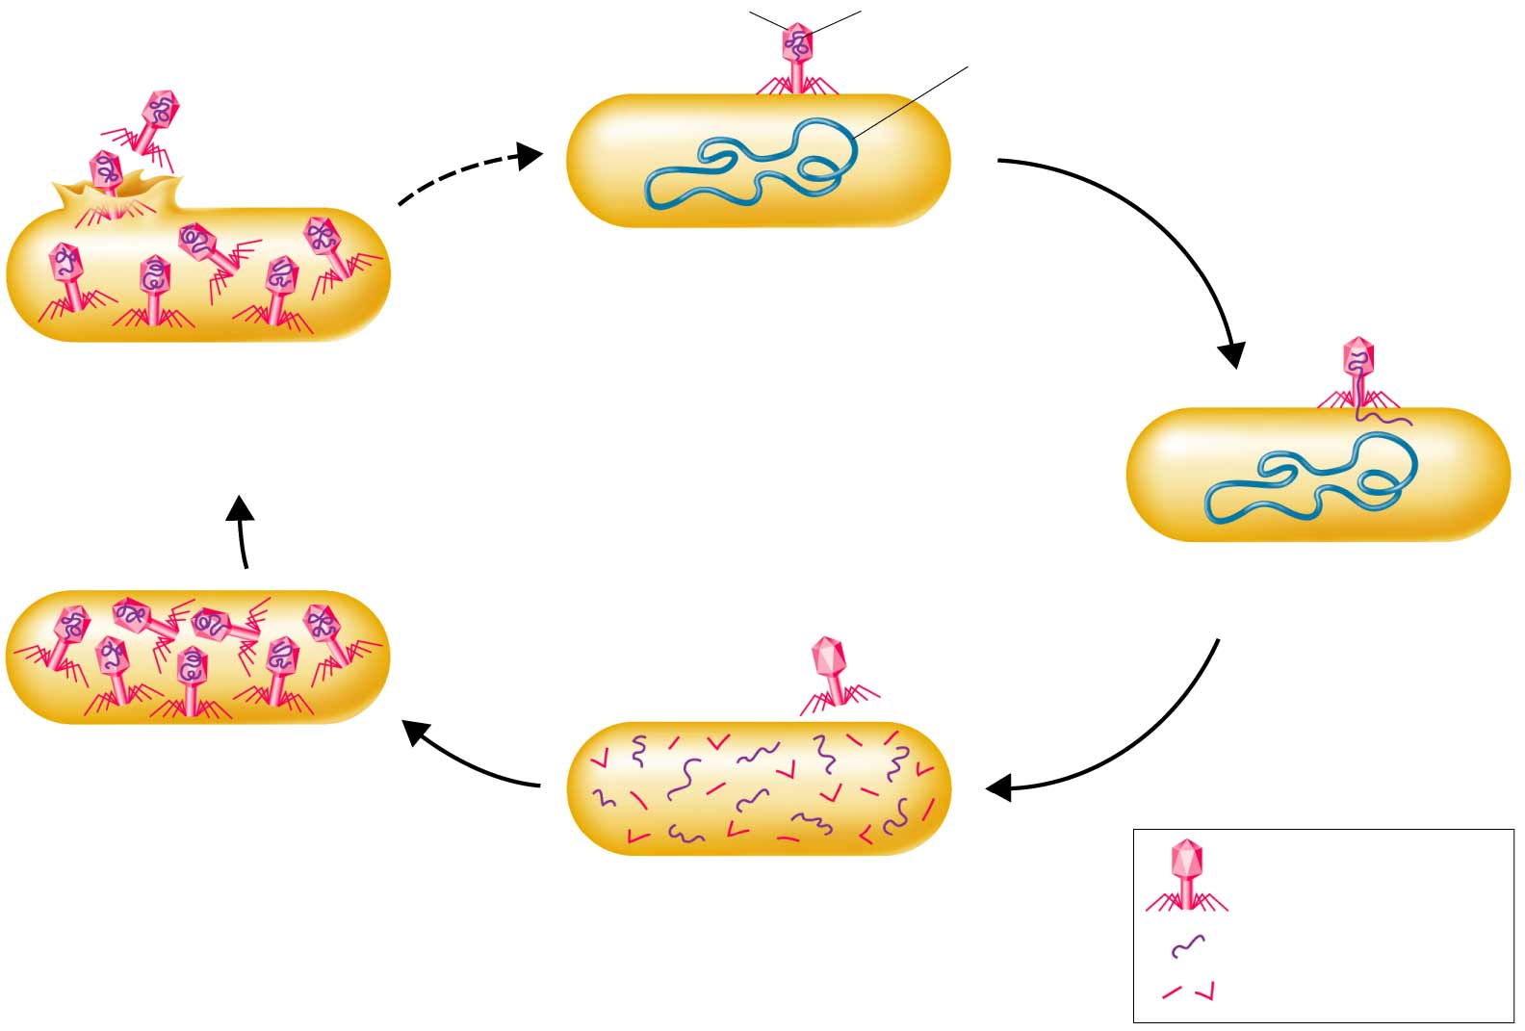
Bacteriophage
Bacteriophage DNA
Bacteriophage protein
Bacteriophage proteins and nucleic acids assemble into complete bacteriophage particles
Bacteriophage enzyme lyses the
bacterium’s cell wall, releasing
new bacteriophage particles that
can attack other cells.
Bacteriophage takes over bacterium’s metabolism, causing synthesis of new bacteriophage proteins and nucleic acids
Bacteriophage injects DNA into bacterium
Bacteriophage attaches to bacterium’s cell wall

Retroviruses
- RNA viruses
- When they infect a cell, they produce DNA copies of their RNA genes.
- Retroviruses have their genetic information copied backwards. RNA DNA
- One retrovirus is HIV.
- Other retroviruses cause cancer in animals and humans.
- The theory is that viruses were not the first living things. They are dependent on living things to survive.

