Review
- Proteins make up all living materials
- Proteins are composed of amino acids – there are 20 different amino acids
- Different proteins are made by combining these 20 amino acids in different combinations
- Proteins are manufactured (made) by the ribosomes
Function of proteins:
- Help fight disease
- Build new body tissue
- Enzymes used for digestion and other chemical reactions are proteins
(Enzymes speed up the rate of a reaction)
- Component of all cell membranes
Making a Protein—First Step
- First Step: Copying of genetic information from DNA to RNA called Transcription
- Why? DNA has the genetic code for the protein that needs to be made, but proteins are made by the ribosomes—ribosomes are outside the nucleus in the cytoplasm.
- DNA is too large to leave the nucleus (double stranded), but RNA can leave the nucleus (single stranded).
- Part of DNA temporarily unzips and is used as a template to assemble complementary nucleotides into messenger RNA (mRNA).
- mRNA then goes through the pores of the nucleus with the DNA code and attaches to the ribosome.
Making a Protein—Translation
- Second Step: Decoding of mRNA into a protein is called Translation.
- Transfer RNA (tRNA) carries amino acids from the cytoplasm to the ribosome.
- These amino acids come from the food we eat. Proteins we eat are broken down into individual amino acids and then simply rearranged into new proteins according to the needs and directions of our DNA.

Translation, cont.,
- A series of three adjacent bases in an mRNA molecule codes for a specific amino acid—called a codon.
- A triplet of nucleotides in tRNA that is complementary to the codon in mRNA—called an anticodon.
- Each tRNA codes for a different amino acid.
- mRNA carrying the DNA instructions and tRNA carrying amino acids meet in the ribosomes.
- Amino acids are joined together to make a protein.
  - Polypeptide = Protein
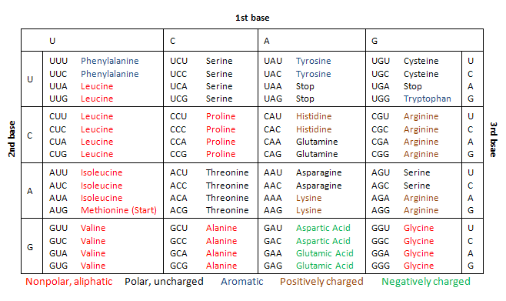
2nd Base
3rd Base
1st Base

